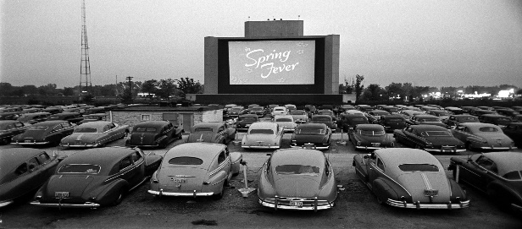
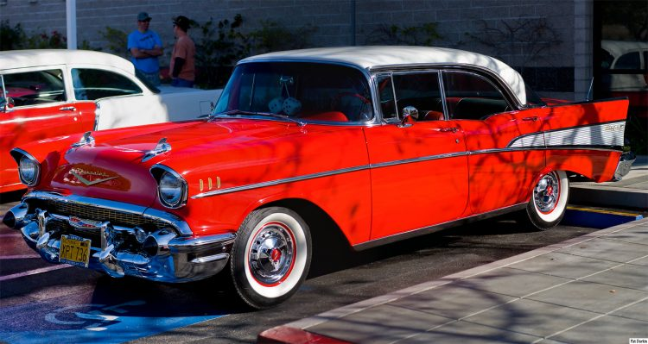
1950s PROSPERITY

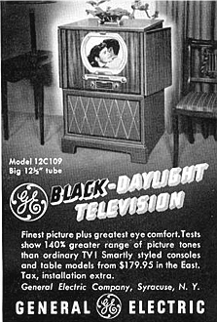
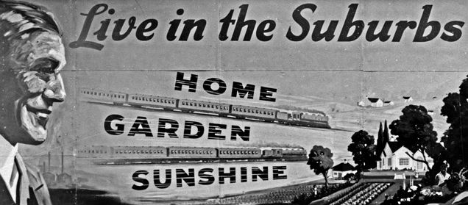
The postwar era witnessed tremendous economic growth and rising social contentment and conformity. Yet in the midst of such increasing affluence and comfortable domesticity, social critics expressed a growing sense of unease with American culture in the 1950s.

Recall Warm-Up
Read the paragraph and analyze the images above to jog your memory. Describe the major economic, social, and political issues from this era.

Economic | Social | Political
1950s PROSPERITY
Need to Know Terms/People
1. Baby Boom- An increase in population by almost 30 million people after WWII in the U.S. This spurred a growth in suburbs and three to four children families (nuclear family with well defined gender roles).
2. GI Bill (Servicemen's Readjustment Act of 1944)- Law passed in 1944 to help returning veterans buy homes and pay for higher education
3. Conformity- Change in belief or behavior in order to fit in with a majority group
4. Consumerism- Large-scale buying, on credit. (TV, Cars) (Middle Class) (Service Jobs) (White Collar)
5. Interstate Highway Act-Signed by President Eisenhower in 1956, law that authorized the spending of $32 billion to build 41,000 miles of highway
6. Prosperity- Successful, flourishing, or thriving condition- especially financially
7. Elvis Presley- White singer born in 1935 in Tupelo, Mississippi; chief revolutionary of popular music in the 1950s, fused black rhythm and blues with white bluegrass and country styles; created a new musical idiom known forever after as rock and roll
8. Sitcoms- A genre of comedy centered on a fixed set of characters who carry over from episode to episode
9. Polio Vaccine- Developed by Jonas Salk and came into use in 1955, acquired immunity used to prevent the polio virus (reduced the number of cases reported each year worldwide from an estimated 350,000 in 1988 to 37 in 2016)
10. In God We Trust- The growth of religious institutions throughout 1950s US, President Eisenhower declared must appear on American currency in 1956

“Culture War”
Compare and contrast the 1920s and 1950s by bullet-pointing economic, social, and political issues that divided Americans during both decades in the Venn Diagram below (example: Flappers).

1920s 1950s

1950s PROSPERITY

1.

2.

3.

4.

