**Name:____________________________________________ Date:_________________________**

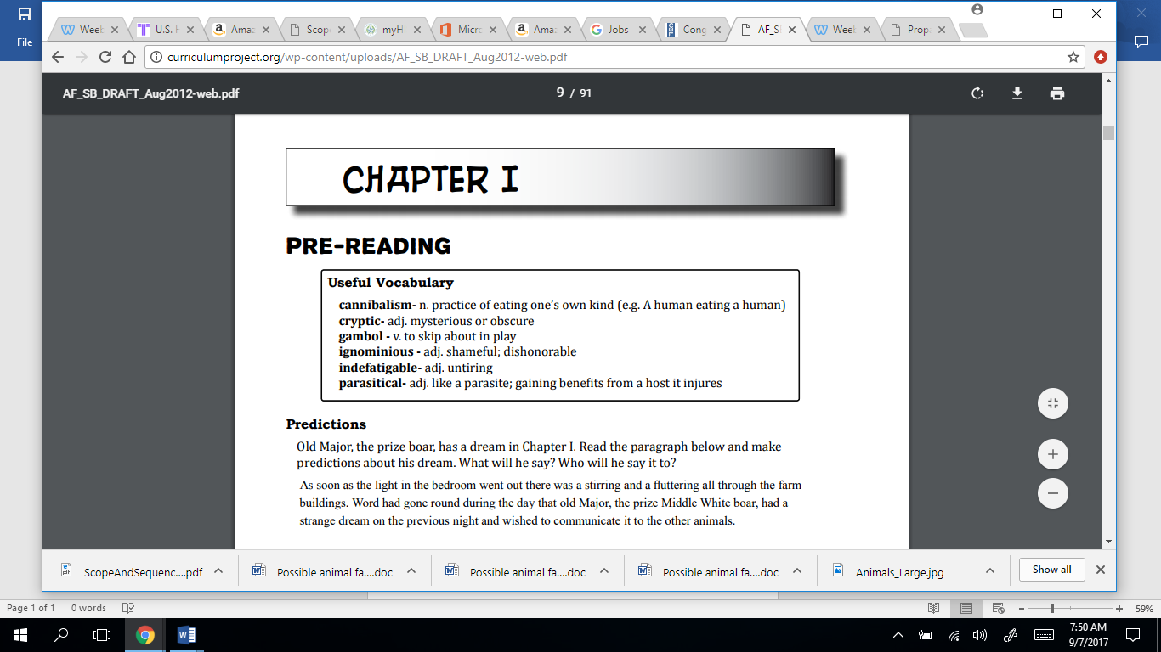

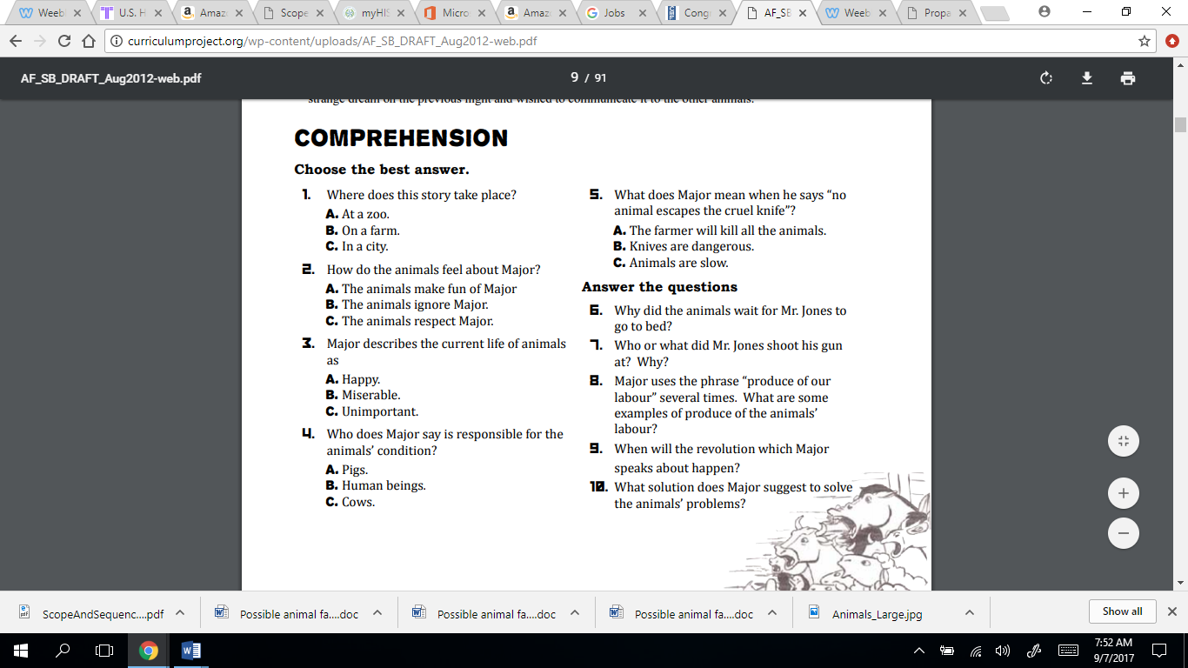

**Analyze**

***Allegory (a story, poem, or picture that can be interpreted to reveal a hidden meaning)***

