Animal Farm Discussion Questions
Allegory
A story, poem, or picture that can be interpreted to reveal a hidden meaning, typically a moral or political one.

Mr. Jones represents… who was…

Old Major represents… who was…

Napoleon represents… who was…

Snowball represents… who was…

Squealer represents… who was…

Boxer represents… who was…

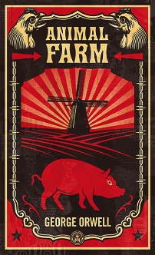
Why do you think Orwell chose to represent political figures as animals?

Is there a protagonist in Animal Farm?

Compare and contrast Napoleon and Snowball. What techniques do they use in their struggle for power? Does Snowball represent a morally legitimate political alternative to the corrupt leadership of Napoleon?

Describe Boxer: What role does he play on the farm? Why does Napoleon seem to feel threatened by him?

Of all of the characters in Animal Farm, are there any who seem to represent the point of view of the author? Which of the animals or people do you think come(s) closest to achieving Orwell’s perspective on Animal Farm?

How is Animal Farm a satire of Stalinism and totalitarianism?

Symbols
Symbols are objects, characters, figures, and colors used to represent abstract ideas or concepts.
Animal Farm
Why did Orwell choose a farm as the novel’s setting? Could the story have taken place anywhere else?

What is important about the title? How is the title of the book a play on words?

The Barn
What does the barn symbolize?

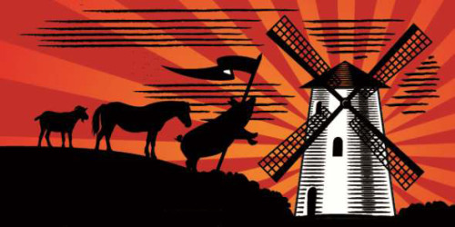
The Windmill
What does the windmill symbolize?

Character Names
Explain the symbolism inherent in the major characters’ names.

Motifs
Motifs are recurring structures, contrasts, and literary devices that can help to develop and inform the text’s major themes.
Songs and Rituals
What songs, poems, and/or slogans are frequently used in the book?

How do these songs serve as propaganda (one of the major tools of social control)?

By making the working-class animals speak the same words at the same time, how do these songs erode (destroy) the animal’s sense of individuality and keep them focused on the tasks by which they will purportedly achieve freedom?

Themes
Themes are the fundamental and often universal ideas explored in a literary work.
Exploitation
Why did the animal’s original ideologies (ideas) of liberation and equality begin to fall apart?

How do the pigs gain the rights to the cows’ milk? Why do the other animals allow this to occur? What does this and other events in the book suggest about the power hierarchy on the farm?

Why do you think there is a human tendency to maintain and reestablish class structures even in societies that allegedly stand for total equality?

What role does “Four legs good, two legs bad,” play in Napoleon’s propaganda? What is its meaning?

“[Squealer] repeated a number of times, ‘Tactics, comrades, tactics!’ skipping round and whisking his tail with a merry laugh. The animals were not certain what the word meant, but Squealer spoke so persuasively, and the three dogs who happened to be with him growled so threateningly, that they accepted his explanation without further questions.” If the animals didn’t understand Squealer’s words, why do you think they accepted his explanation?

What happens when the working class is unable or unwilling to question authority? What are the dangers of a naïve working class?

Deception

Corruption

Historical Connection Overview
Do you think Animal Farm’s message would come across effectively to someone who knows nothing about Soviet history or the conflict between Stalin and Trotsky? What might such a reader make of the story?

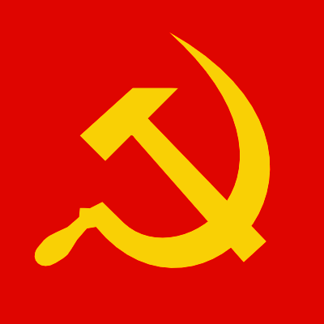

What is Orwell’s main concern with Communism?

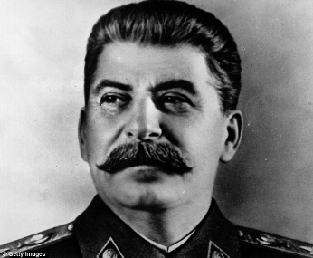

What is Orwell’s main concern with Joseph Stalin?

How will Joseph Stalin take over and become dictator of Soviet Union Russia?

Why do you think people were so willing to support Stalin and communism in Russia?

How will the Soviet Union differ from the United States economically, socially, and politically? Will this create tensions between these two world powers?

The Soviet Union lasted from 1922 to 1991. Why do you think it eventually fell?

Other countries like China, Vietnam, North Korea, and Cuba continue to embrace communism today. Why do you think this is the case?

Animal Farm has been described as a dystopian novel. Why? What are some other examples of fictional works with dystopian settings?

