**CHAPTER 3 HOMEWORK**

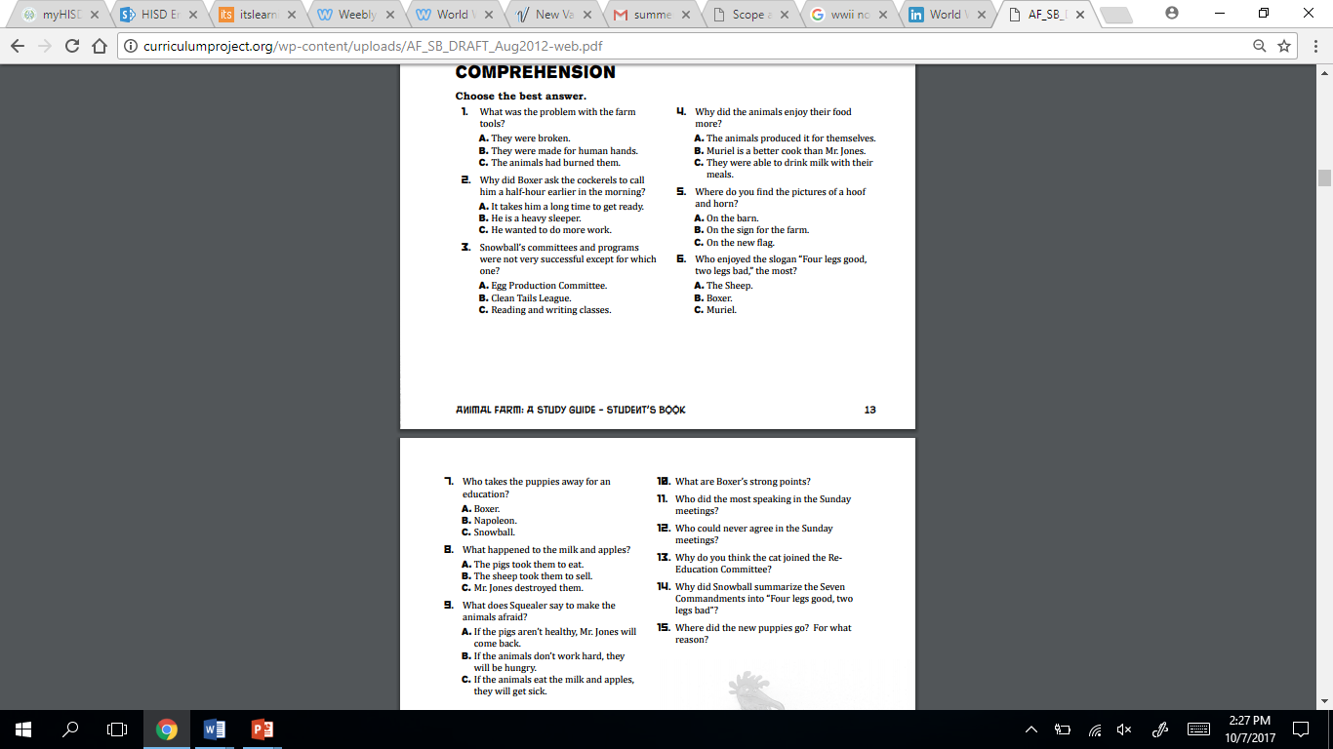

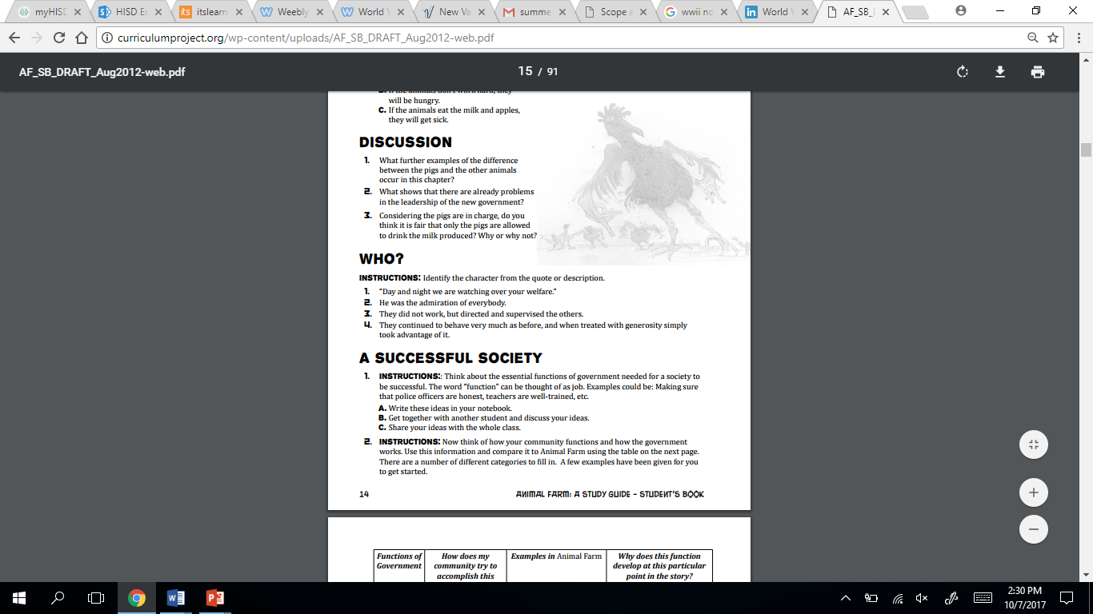

**ANSWERS**

**1.**

**2.**

**3.**