CIVIL RIGHTS HOMEWORK
QUESTION 1: SHIPPS
It is important that the reasons for my action be understood by all our citizens. As you know, the Supreme Court of the United States has decided that separate public educational facilities for the races are inherently unequal and therefore compulsory school segregation laws are unconstitutional.
Our personal opinions about the decision have no bearing on the matter of enforcement; the responsibility and authority of the Supreme Court to interpret the Constitution are very clear. Local Federal Courts were instructed by the Supreme Court to issue such orders and decrees as might be necessary to achieve admission to public schools without regard to race—and with all deliberate speed…
This, unfortunately, has not been the case at Little Rock. Certain misguided persons, many of them imported into Little Rock by agitators, have insisted upon defying the law…
The very basis of our individual rights and freedoms rests upon the certainty that the President and the Executive Branch of Government will support and insure the carrying out of the decisions of the Federal Courts, even, when necessary with all the means at the President’s command….Mob rule cannot be allowed to override the decisions of our courts.
-President Dwight D. Eisenhower Address on Little Rock, Arkansas (1957)
Speaker-
Historical Context (What was going on at that time?)-
Intended Audience-
Purpose-
Point of View-
Significance-

QUESTION 2: STAAR Question

QUESTION 3: Venn Diagram
Compare and contrast Martin Luther King Jr. and Malcom X by filling in the Venn Diagram below.
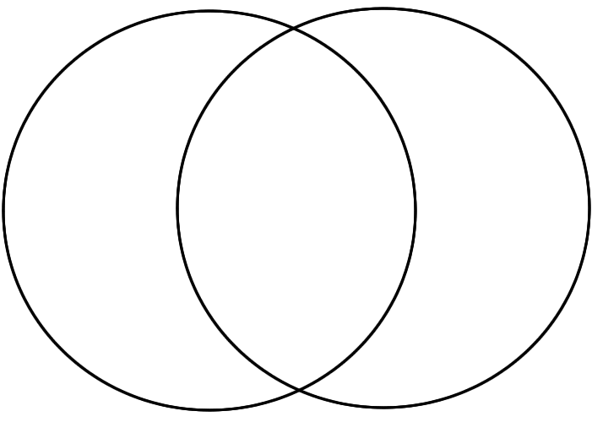

QUESTION 4: OPTIC
Objects:

People:

Time/Title:

Inferences: Because I see ___________________, I can infer…

Conclusion: The most important thing in this image is _______________ because it sends the message that…

QUESTION 5: Matching
A. VOTE (Black Men)
B. Ended segregation in public places and banned employment discrimination
C. Poll Taxes Illegal
D. FREE
E. Prohibits racial discrimination in voting, such as outlawing literacy tests
F. CITIZENS (Equal rights under law)

13th Amendment __________
14th Amendment __________
15th Amendment __________
24th Amendment __________
Civil Rights Act of 1964 __________
Voting Rights Act of 1965 __________

QUESTION 6: STAAR Question

