CIVIL RIGHTS MOVEMENT
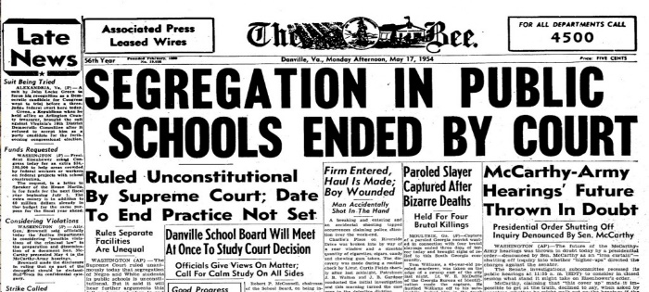

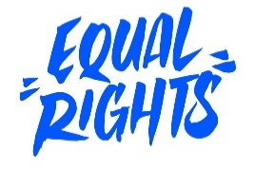

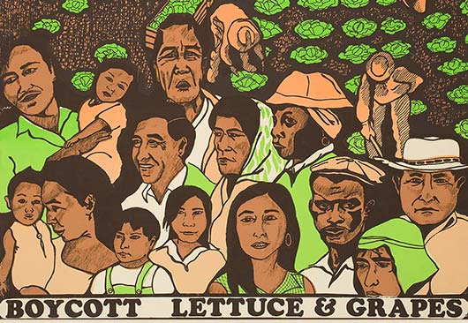
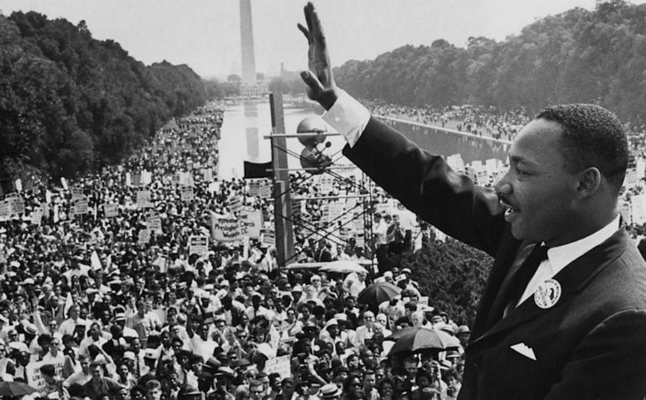
The civil rights movement was a struggle for social justice and equal rights that took place mainly during the 1950s and 1960s. From non-violent civil disobedience, marches, protests, court appeals, boycotts, to armed force, the movement accomplished its goal of ending racial segregation and discrimination laws in the United States and secured the legal recognition and federal protection of the citizenship rights enumerated in the U.S. Constitution and federal law.

Recall Warm-Up
Read the paragraph and analyze the images above to jog your memory. Describe the major economic, social, and political issues from this era.
Economic | Social | Political
CIVIL RIGHTS MOVEMENT
Need to Know Terms/People
- Reconstruction Amendments (1865-1877)- 13th, 14th, 15th Amendments
- Jim Crow Laws- Laws that enforced racial segregation in the South after the end of Reconstruction in 1877
- Disenfranchisement- Poll Taxes and Literacy Tests
- 24th Amendment- Abolished poll taxes in 1964
- Brown v. Board of Education- Landmark 1954 Supreme Court case that ruled segregation in public schools as unconstitutional, overturned Plessy v. Ferguson case of “separate but equal”
- Little Rock Nine- Group of nine African American students enrolled at Little Rock Central High School in 1957 but were prevented from entering the racially segregated school by Orval Faubus, the Governor of Arkansas. They then attended after the intervention of federal troops sent by President Dwight D. Eisenhower.
- Governor George Wallace- Alabama governor who wanted to maintain status quo by supporting segregation/blocked black students from entering University of Alabama/ JFK had to send troops
- Montgomery Bus Boycott- In 1955, after Rosa Parks was arrested for refusing to give up her seat on a city bus, Dr. Martin L. King led a boycott of city busses. After 11 months Supreme Court ruled no more segregation on busses,
- March on Washington- In August 1963, civil rights leaders organized a massive rally in DC to urge passage of President Kennedy's civil rights bill. The high point came when MLK, gave his "I Have a Dream" speech.
- Civil Rights Act of 1964- Ended segregation in public places and banned employment discrimination on the basis of race, color, religion, sex, or national origin (passed by President Lyndon B. Johnson)
- Voting Rights Act of 1965- Prohibits racial discrimination in voting, such as outlawing literacy tests which were historically used to disenfranchise racial minorities (passed by President Lyndon B. Johnson)
- Affirmative Action- Policy of favoring those who tend to suffer from discrimination (jobs or education)
- Title IX- Federal law that prohibits gender discrimination in any school or education program/activity receiving Federal financial assistance (like sports)
- Chicano Mural Movement- Started during the1960s in Southwest. Artists began using the walls of city buildings, housing projects, schools, and churches to depict and support Mexican-American culture.
- Cesar Chavez and Dolores Huerta- Organized labor union (United Farm Workers) for migrant farmworkers that used strikes and boycotts to support their cause (peaceful, non-violent resistance)
- Protests- Sit-Ins, Boycotts, Marches, Civil Disobedience, Freedom Riders, Lobbying, Litigation
- Malcom X- Violence if necessary, Nation of Islam, promoted black supremacy, rejected integration
- Black Panthers- Organization founded in 1966 that practiced militant self-defense of minority communities
- Betty Freidan- Wrote Feminine Mystique, Supported Women’s Feminist Movement

Protests
Create a thinking web that describes the different types of methods used to achieve civil rights goals during the 1960s in the space below.

CIVIL RIGHTS MOVEMENT- STAAR Questions

1.

2.

3.

5.

4.

