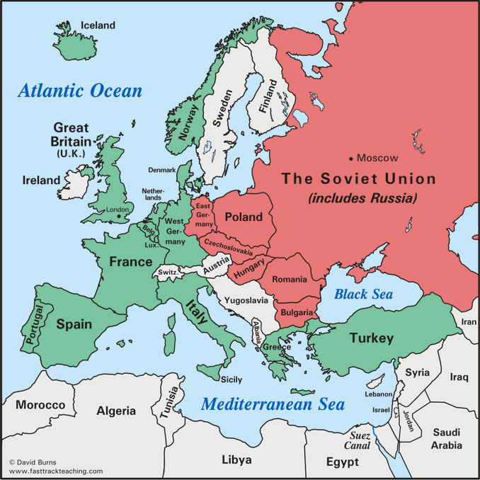
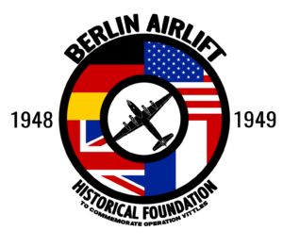
COLD WAR (1940s and 1950s)

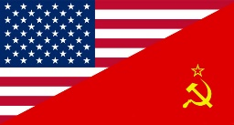

The Cold War is the name given to the relationship that developed primarily between the USA and USSR after World War II. The Cold War was to dominate international affairs for decades and many major crises occurred – the Cuban Missile Crisis, Vietnam, Berlin Wall being just some. The Soviet Union collapsed in 1991 and communism fell in Eastern Europe, causing the Cold War to finally end. The term "cold" is used because there was no large-scale fighting directly between the two sides, but they each supported major regional wars known as proxy wars- such as the Korean War and Vietnam War.

Recall Warm-Up
Read the paragraph and analyze the images above to jog your memory. Describe the major economic, social, and political issues from this era.

Economic | Social | Political
COLD WAR (1940s and 1950s)
Need to Know Terms/People
- Cold War- The state of hostility, without actual warfare, that existed between the United States and the Soviet Union from the end of World War II until the collapse of the Soviet Union. Nuclear weapons= arms race
- Containment Policy- U.S. foreign policy of checking the expansion or influence of the Soviet Union and the spread of communism (domino theory)
- Truman Doctrine- President Truman’s foreign policy of financially supporting Greece and Turkey to help them fight Soviet communist threats
- Marshall Plan- U.S. gave over $13 billion ($140 in current dollar) in economic assistance to help rebuild Western Europe after WWII (used to contain communism as well and spread US influence)
- Berlin Airlift- Supply of West Berlin in Germany by American and British planes during a Soviet blockade in 1948.
- North Atlantic Treaty Organization (NATO)- A defensive military alliance with the West European nations and the US. (opposite was Warsaw Pact)
- McCarthyism- Known as the Second Red Scare, the practice of making accusations of subversion or treason against those believed to be Communists without proper regard for evidence (Senator Joseph McCarthy)
- House Un-American Activities Committee (HUAC)- A committee of the U.S. House of Representatives to investigate alleged disloyalty and subversive activities on the part of private citizens, public employees, and those organizations suspected of having communist ties. Investigated communist influence in the movie world.
- Sputnik I- Created by Soviet Union, first satellite to orbit the Earth launched in 1957 causing the “space race”
- Iron Curtain- The "boundary" that divided Soviet-dominated Eastern Europe from Western European nations
- Communism- Economic and social system in which all (or nearly all) property and resources are collectively owned by a classless (completely equal) society; no private property; distribution of goods would be based upon the principle “From each according to his ability, to each according to his needs”; government has control over all business (opposite of Capitalism)
- Korean War- 1950 to 1953 war between North Korea (with the support of China and the Soviet Union) and South Korea (with mostly the support of the U.S.) (38th Parallel) (Armistice signed in 1953) (Fired General McArthur)

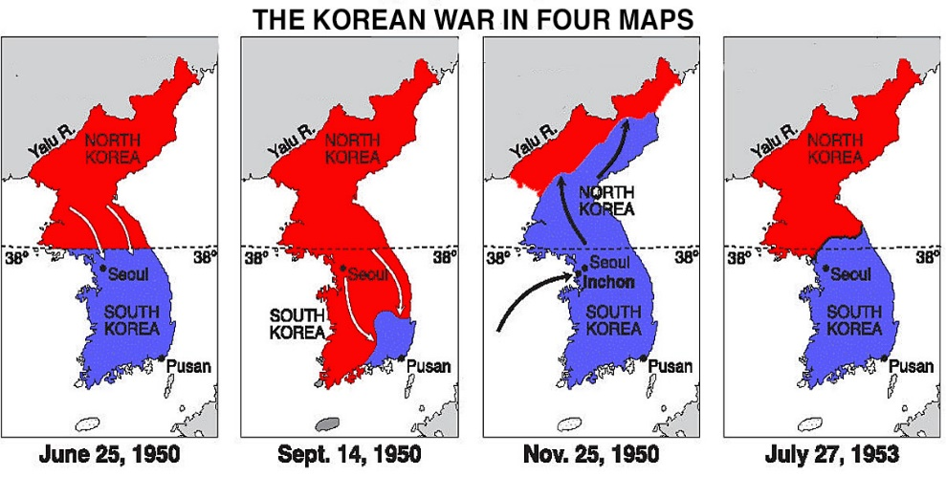
Korean War

Who?

What?

When?

Where?

Why?

COLD WAR (1940s and 1950s)-STAAR Questions

1.

2.

3.

4.

