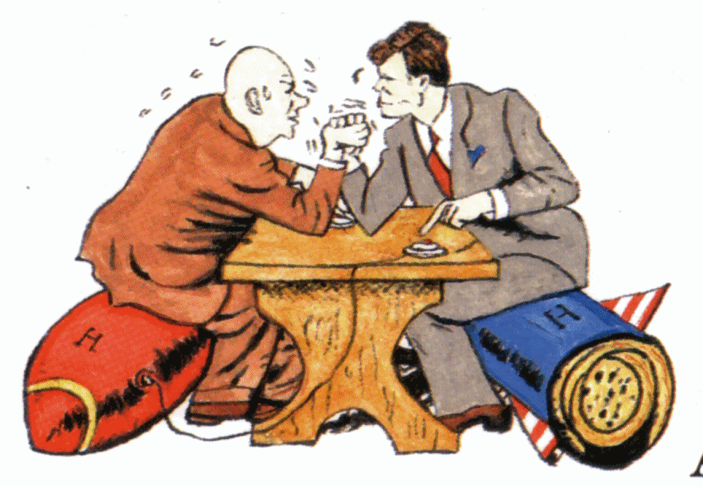
COLD WAR UNIT TEST REVIEW
- Cold War (What was it, who was it between, exc.)
- NATO (North Atlantic Treaty Organization)
- Berlin Airlift
- Truman Doctrine $$$
- Marshall Plan $$$
- McCarthyism (Senator Joseph McCarthy)
- HUAC (House Un-American Activities Committee)
- Sputnik I
- Space and Arms Race
- 1950s Prosperity $$$
- Post-War Economic Boom after WWII
- GI Bill college and housing help for veterans
- Interstate Highway Act
- Baby Boom
- Consumerism
- Rise of the Middle Class
- Culture (Nuclear Family, TV, Suburbs, Elvis, Rock and Roll, Religious Revival “In God We Trust” added)
- Polio Vaccine (Jonas Salk)
- Korean War (United Nation with U.S. supported South Korea)
- Cuban Missile Crisis (JFK)
- The Great Society (LBJ)
- “War on Poverty”
- Medicare
- Medicaid
- Food Stamp Act
- Due Process (rights if accused of a crime such as 6th amendment- right to council which is an attorney/lawyer)
- Domino Theory
- Policy of Containment
- Vietnam War
- Gulf of Tonkin Resolution
- Role of the Media
- Vietcong (Communist in the South who were helping North Vietnam) (Used Ho Chi Minh Trail)
- Tet Offensive
- Anti-War Protests/Demonstrations (Kent State Shooting)
- Military Draft Draft Card Burnings Protest
- Military Draft 26th Amendment
- Vietnamization
- Fall of Saigon
- War Powers Resolution
- Pentagon Papers
- Counterculture (hippies, college student protests/teach-ins)
- Nixon Administration
- “Silent Majority”
- China Relations
- Policy of Détente
- Watergate Scandal
- Endangered Species Act
- Environmental Protection Agency (EPA)
- Three Branches of Government (Legislative, Executive, Judicial)
20. ***Describe the impact of events such as the Gulf of Tonkin Resolution and the War Powers Resolution on the relationship between the legislative and executive branches of government***
QUICK TIMELINE
1945
U.S. Use Atomic Bombs Against Japan (developed in secret Manhattan Project)
World War II Ends
Europe Destroyed
Germany Split
US and USSR= world powers
1947
Cold War Begins (Soviet Union versus United States) (Iron Curtain)

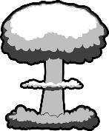

1947-48
Start trying to CONTAIN COMMUNISM/ DOMINO THEORY
Marshall Plan $$$
Truman Doctrine $$$

1950s (Vietnam War Starts)
U.S. NOT combative YET, just sending aid/supplies to South Vietnam

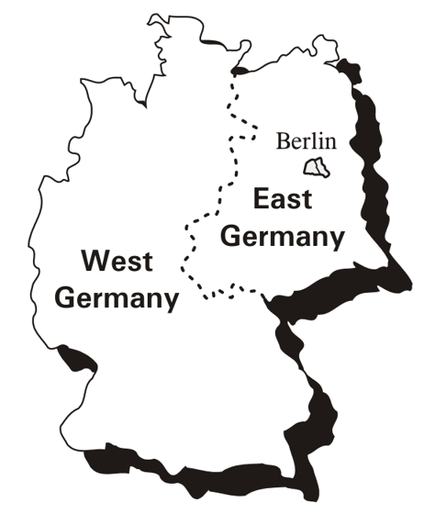
1948-49
Berlin Airlift to West Berlin
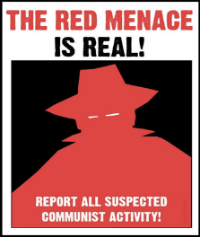
1950s
McCarthyism in America
Second Red Scare
HUAC
“Witch Hunts” for comm.

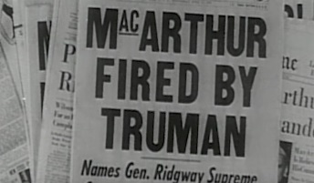
1950-1953
Korean War
Contain communism
38th Parallel
Armistice Signed
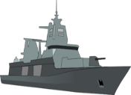
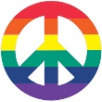
War Powers Resolution (1973)
Up to 60 days, Mr. President!
26th Amendment (1971)
18 for military= 18 to vote
1964 (US Combat in Vietnam)
Gulf of Tonkin Resolution
Nixon’s “Vietnamization”
“Peace With Honor”, leave war slowly but he also did huge bombing campaigns
Nixon Administration (1969- 1974)
Policy of Détente
Watergate Scandal
Anti-War Protests and Counter Culture
Draft Card Burnings, College Teach-Ins
Kent State Shooting
Hippies
LBJ (1963-1969)
“The Great Society”= get rid of poverty
JFK (1961-1963)
“The New Frontier” (space, civil rights)
Bay of Pigs Failure
Cuban Missile Crisis (NAVAL BLOCKAID)
Berlin Wall Issues
1975 (Fall of Saigon in Vietnam)
U.S. signed peace treaty and left in 1973

1957 Sputnik I Launched
=Space Race (Moon Landing in 1969)

1950s
GI Bill
Baby Boom
Economic Prosperity, Consumerism
Socially Conservative and Conformity
Rock and Roll, TV, Family, Suburbs
1968 (Tet Offensive in Vietnam)
Media and the “Credibility Gap”

