Kennedy and Johnson Years Homework
QUESTION 1
We stand today on the edge of a New Frontier — the frontier of the 1960s, the frontier of unknown opportunities and perils, the frontier of unfilled hopes and unfilled threats. ... Beyond that frontier are uncharted areas of science and space, unsolved problems of peace and war, unconquered problems of ignorance and prejudice, unanswered questions of poverty and surplus.
-John F. Kennedy, 1960, Democratic National Convention Address

According to his New Frontier speech above, list four policies or goals JFK sought to achieve as becoming the new U.S. President in 1960.
1.

2.

3.

4.

QUESTION 2
Objects:

People:

Time/Title:

Inferences: Because I see ___________________, I can infer…

Conclusion: The most important thing in this poster is ______________ because it sends the message that…

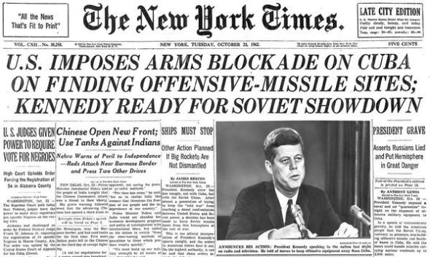

QUESTION 3

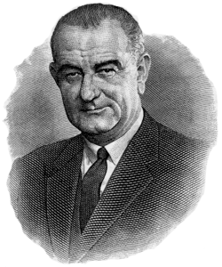

*Use the Great Society chart above to answer the following questions*

QUESTION 4
What did President Lyndon B. Johnson hope to accomplish through his Great Society programs?

QUESTION 5
How did President Johnson’s social programs build upon the goals and legacy of Kennedy?

QUESTION 6
Why do you think President Johnson was successful at getting social welfare programs passed?

QUESTION 7

