Korean War 6 Degrees of Separation Poster Project

Big Question: How did the 1950’s Korean War lead to current negative foreign relations between the U.S. and North Korea?
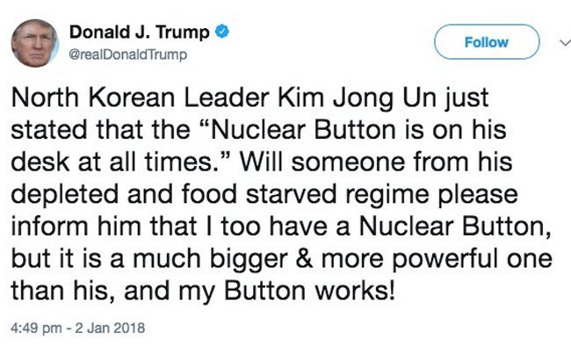

Instructions
- With a partner, copy the Korean War 6 Degrees of Separation visual on your poster board.

- You have six circles. In the first circle, you must start with the date 1945 and explain what happened in Asia directly after World War II. In the last circle, you must end with the date 2018 and explain America’s current relationship with North Korea. The goal is to build a connection between these two circles with a logical series of events. Research the causes and effects of the Korean War to build this connection in the remaining four circles. What happened in between to get to President Trump’s saucy tweets?

- Each circle MUST have the following:
- A title (main idea of circle)
- Date
- At least three complete sentences describing the event
- At least one printed or drawn image illustrating the event or person involved
- Reference: paraphrase or copy a quote from at least one Korean War primary source document on my website and explain how it supports the circle’s main idea (must give author and date of each source used, can’t use same source more than twice)

- REMEMBER each circle should be in chronological order and show a valid/logical cause and effect connection.

***I DID THE FIRST CIRCLE FOR YOU!! LOOK AT IT FOR AN EXAMPLE!!
Korean War 6 Degrees of Separation
CIRCLE ONE
***COPY THIS ON POSTER BOARD***

World War II Effects on the Pacific

1945

Japan lost WWII and had to give up control of Korea. The Soviet Union and the U.S. divided Korea into two parts at the 38th parallel. North Korea became a Soviet and Chinese supported communist regime under the leadership of Kim Il-sung and South Korea became a U.S. supported democratic state.

Kim Il-sung believed Korea should “teach all of our people to hate U.S. imperialism.” He
wanted to reunify the divided country and not have South Korea controlled by the U.S.

Korean War 6 Degrees of Separation
***COPY THIS ON POSTER BOARD***

