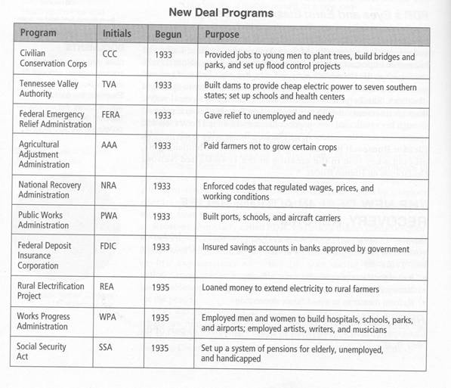

Securities and Exchange Commission (SEC)- Federal agency that regulates the stock market. It protects investors by making the U.S. market transparent and punishes businesses who participate in insider trading, deliberate manipulation of the markets, and selling stocks and bonds without proper registration.

