The New Deal

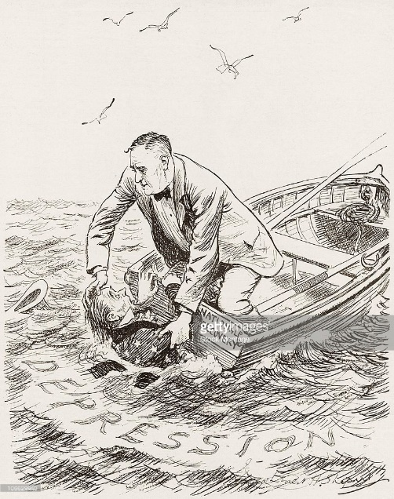
Objects:

People:

Time/Title:

Inferences: Because I see ___________________, I can infer…

Conclusion: The most important thing in this cartoon is _____________ because it sends the message that…

Objects:

People:

Time/Title:

Inferences: Because I see ___________________, I can infer…

Conclusion: The most important thing in this cartoon is _____________ because it sends the message that…

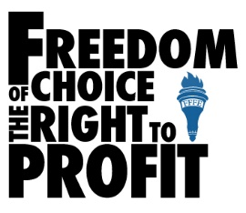
What ideas is the U.S. economy founded on?

What ideas is the U.S. government founded on?

NEW DEAL PROGRAMS
How Did the U.S. Government Help the Poor in the 1930s?

New Deal Program | How the Program Helped Provide Relief, Recovery or Reform
Civilian Conservation Corps (CCC) | The CCC created outdoor jobs for young, jobless men. They lived in work camps and earned $30 a month. 2.5 million young men were employed by the CCC to work on projects that protected the natural environment.
Farm Credit Administration (FCA) | The FCA made loans to farmers who could not pay their debts and were about to lose their farms.
Tennessee Valley Authority (TVA) | By building dams on the Tennessee River, the TVA ended floods, improved farmland, and created jobs. This authority is still here today.
Agricultural Adjustment Act (AAA) | The AAA provided direct payments to farmers who agreed to reduce their production of certain crops. Lower production helped to increase crop prices.
Works Progress Administration (WPA) | The WPA hired workers to build hospitals, schools, etc. It also created jobs for writers and artists.
Federal Deposit Insurance Corporation (FDIC) | The FDIC was created to restore Americans’ confidence in the nation’s banking system. It guaranteed the safety of accounts in the event of a bank failure.
Securities and Exchange Commission (SEC) | The SEC was set up in 1934 to regulate the nation’s stock exchanges.
Social Security Administration (SSA) | The SSA provided money for retired workers, people who lost their jobs, dependent children, and those with disabilities.
National Recovery Administration (NRA) | The NRA was set up to help American industries prepare “codes of fair competition” that established standard wages, prices, and work hours.
Public Works Administration (PWA) | The PWA paid construction workers to build dams, ports, and other huge “public works.”

- Relief – this means to ease the suffering of the poor and unemployed
- Recovery – this means to get the economy working again; to get better
- Reform – the means to make sure that a “great” depression never happens again.

New Deal Program Questions (EXPLAIN YOUR ANSWERS)
- Does it look like the federal government is willing or unwilling to spend money to end the Depression? Why or why not?

- Is the New Deal an example of laissez-faire capitalism? Why or why not?

- Which two programs are most alike?

- Which programs call for public works projects?

- How do the New Deal programs provide evidence for this statement: “The Federal Government, not private business or charities, is best able to end the Great Depression.”

