Pearl Harbor
SOURCE #1
Tokyo, November, 1941
Setting: Headquarters of the Japanese Imperial High Command in Tokyo.

Admiral Yamamoto: “Gentlemen, we enjoy a profitable friendship with the U.S. Americans supply us with oil, scrap iron, and many other materials. We need these things, and the United States needs our business. America still suffers from an economic depression. I don’t think that they can afford to stop trading with us. Americans are reasonable. I don’t think they are looking for trouble. Let our ambassadors, not our guns, convince the Americans to mind their own business. Gentlemen, war is costly. The United States may not be as weak as she appears.”

The men spoke to one another. Suddenly an official rushed into the room and gave a message to the prime minister. The room was hushed as Tojo read the message.

Tojo: “The United States has turned down every one of our demands. The message says that, if we wish to continue to trade, we must give up the parts of Asia that we now protect. They order us about as if we were mindless children. We have taught the Russians and the Chinese to respect us. Now I say that it is time to let the Americans feel our sting! We will invade their bases in the Philippines.”

SOURCE #2
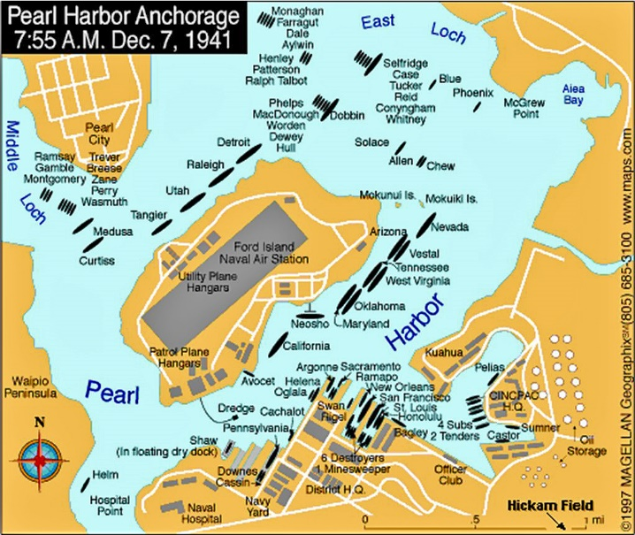
Maps
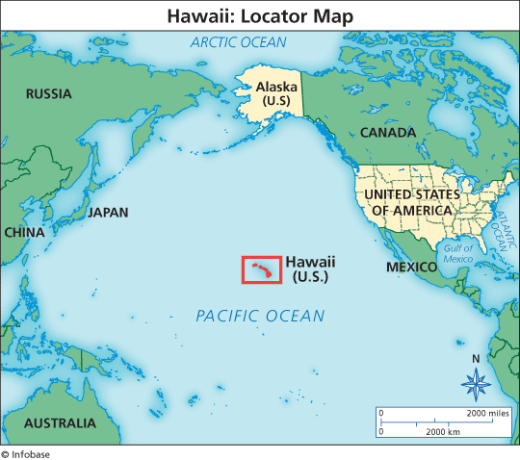

SOURCE #3
USS Arizona
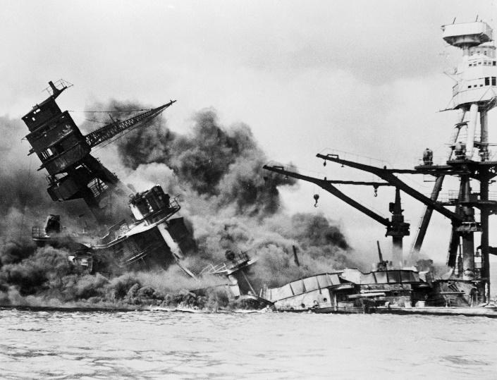
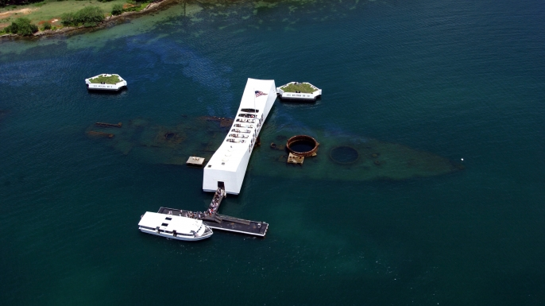

SOURCE #4
F.D.R. Address to Congress
December 8, 1941
Mr. Vice President, and Mr. Speaker, and Members of the Senate and House of Representatives:
Yesterday, December 7, 1941 -- a date which will live in infamy -- the United States of America was suddenly and deliberately attacked by naval and air forces of the Empire of Japan.
The United States was at peace with that Nation and, at the solicitation of Japan, was still in conversation wit its Government and its Emperor looking toward the maintenance of peace in the Pacific. Indeed, one hour after Japanese air squadrons had commenced bombing in the American Island of Oahu, the Japanese Ambassador to the United States and his colleague delivered to our Secretary of State a formal reply to a recent American message. And while this reply stated that it seemed useless to continue the existing diplomatic negotiations, it contained no threat or hint of war or of armed attack.
It will be recorded that the distance of Hawaii from Japan makes it obvious that the attack was deliberately planned many days or even weeks ago. During the intervening time the Japanese Government has deliberately sought to deceive the United States by false statements and expressions of hope for continued peace.
The attack yesterday on the Hawaiian Islands has caused severe damage to American naval and military forces. I regret to tell you that very many American lives have been lost. In addition American ships have been reported torpedoed on the high seas between San Francisco and Honolulu.
Yesterday the Japanese Government also launched an attack against Malaya.
Last night Japanese forces attacked Hong Kong.
Last night Japanese forces attacked Guam.
Last night Japanese forces attacked the Philippine Islands.
Last night the Japanese attacked Wake Island. And this morning the Japanese attacked Midway Island.
Japan has, therefore, undertaken a surprise offensive extending throughout the Pacific area. The facts of yesterday and today speak for themselves. The people of the United States have already formed their opinions and well understand the implications to the very life and safety of our Nation.
As Commander in Chief of the Army and Navy I have directed that all measures be taken for our defense.
But always will our whole Nation remember the character of the onslaught against us.
No matter how long it may take us to overcome this premeditated invasion, the American people in their righteous might will win through to absolute victory. I believe that I interpret the will of the Congress and of the people when I assert that we will not only defend ourselves to the uttermost but will make it very certain that this form of treachery shall never again endanger us.
Hostilities exist. There is no blinking at the fact that our people, our territory, and our interests are in grave danger.
With confidence in our armed forces- with the unbounding determination of our people- we will gain the inevitable triumph- so help us God.
I ask that the Congress declare that since the unprovoked and dastardly attack by Japan on Sunday, December 7, 1941, a state of war has existed between the United States and the Japanese Empire.

Source #1
1.) What is an embargo?

2.) Why did the U.S. declare an embargo on Japan?

3.) Why did Japan decide to attack the U.S.?

Source #2
4.) Why do you think Japan decided to make its first attack on Hawaii?

5.) Why do you think Japan choose to specifically target Pearl Harbor in Hawaii?

Source #3 (OPTIC)
Objects-

People-

Title/Time- USS Arizona (1941)

Inference-

Conclusion-

Source #4 (SHIPPS)
Source-

Historical Context-

Intended Audience-

Purpose-

Point of view-

Significance-
World War II Daily Quiz

1.) World War II started on September 1st, __________________ when Hitler invaded _________________.

2.) World War II was fought between the _____________ Powers and the ________________ Powers.

3.) Name THREE countries that were in the Axis Powers.

4.) Name THREE countries that were in the Allied Powers.

5.) WWII was fought on the continents of _______________________ and _____________________.

6.) When did the U.S. enter World War II?

7.) Why did the U.S. enter World War II?

8.)

9.)

10.)

