The Jones Daily Tribune
EXTRA!
EXTRA!

U.S. FIGHTS IN THE GREAT WAR!

Article #1 Headline
Summary…

Picture of Doughboy.

General Pershing Interview…

Article #2 Headline
Define…

New weapons list…

Describe one new weapon…

Trench Warfare Weapon Picture

Trench Warfare Tech Changes the Nature of the War!

Trench Warfare Picture
Technology changed the nature of the war because…

Excepts...

Article #3 Headline
Summary of the Battle of Argonne Forest…

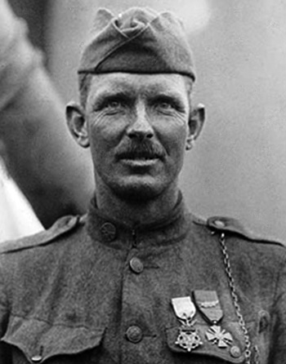

Alvin York Interview…

Access the Battle of the Argonne Forest Toolkit to help you with the information you need.

Alvin York Bio Poem…
You will need a headline or title for your article.
Rubric:

