American Expeditionary Force Toolkit
I. General John J. Pershing
JOHN J. PERSHING

John J. Pershing was born in Missouri. He graduated from West Point Military Academy in 1886 and was commended for his leadership skills.

Pershing was assigned to the 6th U.S. Cavalry stationed in the New Mexico Territory. In 1895, he took command of the 10th Cavalry Regiment (one of the original Buffalo Soldier regiments), composed of African-American soldiers under the command of white officers. At the start of the Spanish-American War, Pershing fought with the 10th Cavalry on San Juan Hill in Cuba.

In 1914, Pershing was assigned to Fort Bliss, Texas and was responsible for securing the U.S.-Mexican border. In 1916, he led the failed expedition into Mexico in search of Pancho Villa.

While at Fort Bliss, Pershing received a telegram telling him of a fire in San Francisco that resulted in the deaths of his wife and three young daughters. Only his six year old son survived. Many said that Pershing never recovered from their deaths.

At the start of U.S. involvement in WWI, President Wilson named Pershing as the commander of the AEF. He was promoted to general and was responsible for organizing, training, and supplying the army that grew from 27,000 inexperienced men to an army of over 2,000,000 men.

Pershing and the AEF arrived in France in 1917. American forces first saw serious action at the Second Battle of the Marne in 1918. Pershing openly scorned the trench warfare of the Western Front, believing that American skill would enable them to avoid the costly and senseless fighting over no man’s land. American successes were credited to Pershing and he became the most famous American leader of WWI. In recognition of his service, the President promoted Pershing to General of the Armies of the United States, the highest rank possible for any member of the U.S. armed forces.

II. Log into: theworldwar.org
Click on “interactive timeline”
Scroll through and look at the events that deal with weapons. Pay special attention to these dates:
- June 25, 1917
- October 21, 1917
- May 28, 1918
- June 6, 1918
- September 12, 1918

III. Pictures of Doughboys

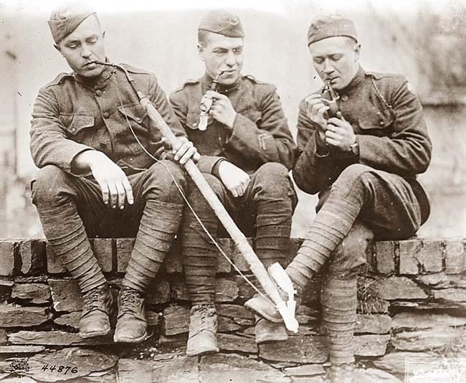
http://www.old-picture.com/

