Battle of the Argonne Forest – Media Toolkit
I. Log into: theworldwar.org and click on “interactive timeline”
Scroll through and look at the events that deal with weapons. Pay special attention to this date:
- September 26, 1918

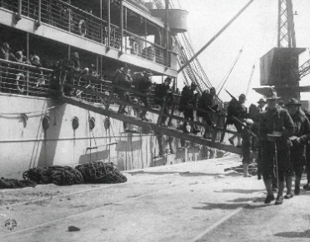
II. Blood, Mud, Concrete, and Barbed Wire: The Meuse-Argonne Offensive
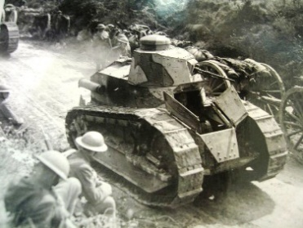
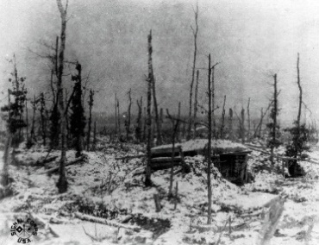

The Meuse-Argonne Offensive in September 1918 was part of the Allied effort to attack the Germans and force them out of France and back into Germany. The plan sought to take advantage of the arrival of the American Expeditionary Force under General Pershing. After four years of fighting, the arrival of the U.S. Forces gave the Allies fresh troops and numerical superiority.
The Germans had developed an elaborate defensive system with a dense network of wire entanglements, machine-gun positions, and concrete fighting posts. In between the trench lines, the Germans had a series of strong points in the woods and knolls.
On September 26, 1918, Pershing launched his attack. Despite heavy fog, rugged terrain, and the network of barbed wire, American Soldiers quickly overran the Germans’ positions. For the rest of September, heavy rains turned the terrain to mud, which bogged down tanks and artillery and slowed resupply efforts. German artillery rained down fire from the heights of the Meuse and the Argonne Forest. The battle became a continuous series of bloody, hard-fought engagements.
Despite these problems, the Army advanced into the German lines by the end of September, fighting through some of the strongest positions on the Western Front and capturing 9,000 prisoners and large amounts of supplies and equipment.
The fighting ended at the eleventh hour of the eleventh day of the eleventh month—November 11, 1918. When it ended, the Meuse-Argonne Campaign was the greatest battle that the U.S. Army had ever fought. Almost 1.25 million American troops had participated during the course of the 47-day campaign. American casualties were high—over 117,000—but the results were impressive. The Army had driven forty-three German divisions back over some of the most difficult terrain and most heavily fortified positions on the Western Front, while inflicting over 120,000 casualties. There is little doubt that the success of the American forces during this battle was a major factor in Germany’s surrender.
Adapted From:
Stewart, Richard W., ed. “Chapter 1: The U.S. Army in World War I, 1917-1918.” American Military History Vol. II: The United States Army in a Global Era, 1917-2003. Washington, DC: Center of Military History, 2005. pgs. 43-49. http://www.history.army.mil/books/AMH-V2/AMH%20V2/Chapter1.htm#b9.

III. ALVIN YORK
“Sir, I am doing wrong. Practicing to kill people is against my religion.” Alvin York

Alvin York was one of the most famous soldiers of WWI. He earned the Congressional Medal of Honor by attacking a German machine gun nest singlehandedly, capturing 132 prisoners and 35 machine guns. Asked how he had done this all by himself, he answered: “I surrounded ‘em.”

York was from the mountains of Tennessee. Alvin left school after the third grade to work in his father’s shop. When his father died, Alvin became the main source of financial support for his family. He was an expert rifleman and was a rebellious young man. However, when he fell in love with a deeply religious young woman, Alvin gave up his wild lifestyle and became an elder in the Church of Christ in Christian Union. This church took literally the commandment “Thou shalt not kill.”

When York was drafted into the army in WWI, he declared himself a conscientious objector [someone who objects to serving in war]. But the government refused and sent him to Georgia for training where he showed his skill with a rifle.

A member of the 82nd Infantry Division, York took part in the Battle of the Argonne Forest. The 82nd was stopped by German machine gun fire. York joined 16 other Americans on a mission to take out the enemy guns. Soon the detail was down to 8 men with York in charge. York crawled to a point where he could see the enemy. He eliminated 17 Germans before the others realized that York was alone and nearly out of ammunition. The Germans charged with fixed bayonets, but York picked off all 8 of them with his pistol. A German officer agreed to surrender if York would stop shooting. Soon York and the 7 surviving Americans marched 132 German prisoners to headquarters.

American officers refused to believe York’s story until they went to the battlefield and found 25 dead Germans and 35 abandoned machine guns. For his heroism, York was awarded medals for valor [bravery] from several countries including the U.S. Congressional Medal of Honor, a parade in New York City, and a visit with President Woodrow Wilson.

(adapted from United States History – American Portraits Glencoe Division of McGraw-Hill, 1992)
