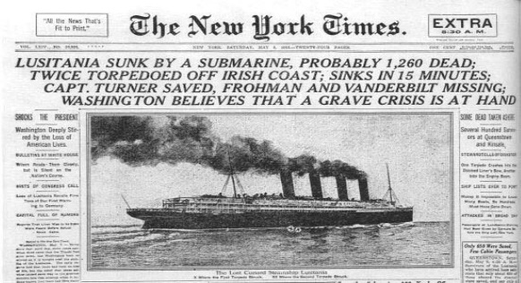
WORLD WAR I

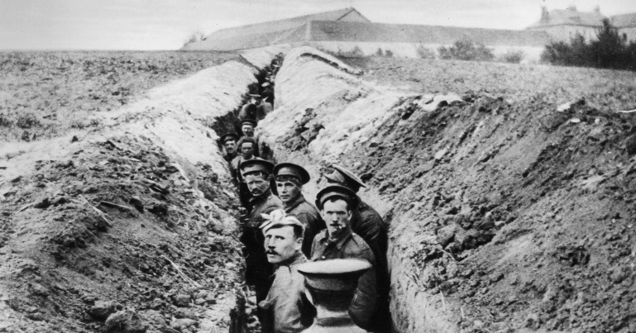
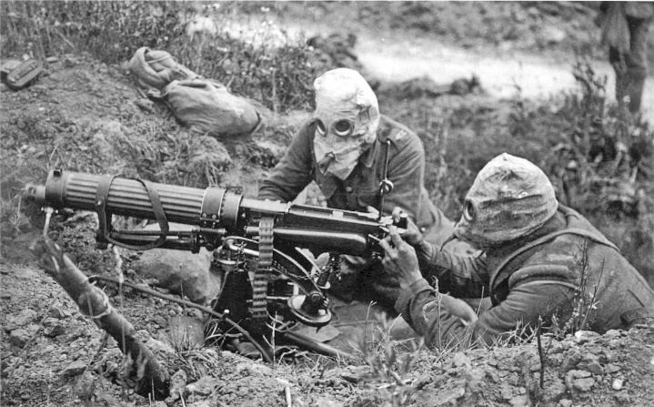
Also called the Great War, World War I was a global war originating in Europe that lasted from 1914 to 1918. The world’s great powers assembled in two opposing alliances: the Allies and the Central Powers. Because of technological and industrial sophistication, combat was horribly gruesome and Europe was stuck in a tactical stalemate for much of the conflict. The U.S. entered the war in 1917 on the side of the Allies and helped to defeat the Central powers. Overall, WWI resulted in over 41 million casualties, created major political changes, and left unresolved rivalries which ultimately contributed to the start of the Second World War.

Recall Warm-Up
Read the paragraph and analyze the images above to jog your memory. Describe the major economic, social, and political issues from this era.

Economic | Social | Political
WORLD WAR I
Need to Know Terms/People
- Allied versus Central Powers- Alliances (Allied= Great Britain, France, and Russia from the start of WWI and later Belgium, Italy and the United States) versus (Central= Germany, Austria-Hungary, and the Ottoman Empire)
- Archduke Franz Ferdinand of Austria- Heir presumptive to the Austro-Hungarian throne who was assassinated by Serbian nationalists in 1914 starting WWI (Austria-Hungary declared war against Serbia caused network of alliances to do the same)
- Neutrality- Not taking sides, especially in a war or dispute (US tried to remain neutral at the start of WWI)
- Trench Warfare- Form of fighting where two sides fight each other from opposing trenches (long narrow ditches), tanks had to be used to break up stalemate, chemical warfare common with poison gases being used such as mustard gas; machine guns
- Zimmerman Telegram- 1917 message British intercepted from the German government to the Mexican government offering German support if Mexico declared war against the U.S. and offered to return land Mexico had lost to the U.S
- Lusitania - British ocean liner carrying Americans that was sunk off the coast of Ireland by German U-Boats in 1915 due to Germany’s policy of unrestricted submarine warfare
- Battle of Argonne Forest- Major part of the final Allied offensive of WWI that stretched along the entire Western Front with lasted 47 days and brought an end to WWI. Largest battle in U.S. military history, involving 1.2 million American soldiers
- American Expeditionary Forces- Under the command of General John J. Pershing, American military force that fought alongside French and British troops against the German Empire in WWI and helped win the Battle of Argonne Forest in 1918.
- Russian Revolution- 1917 uprising destroyed the Tsarist (Czar) autocracy and led to the rise of communism and Soviet Union
- Armistice- A state of peace agreed to between opponents so they can discuss peace terms (signed in 1918)
- Fourteen Points - Woodrow Wilson's peace plan that was easy on the German’s punishment for WWI and included: people all over the world are to determine their own fate (self-determination), no colonial powers grabbing nations, free trade, no secret pacts, freedom of the seas, arms reduction, and creation of the League of Nations. (US Congress did not approve/join)
- Treaty of Versailles- The treaty imposed on Germany by the Allied powers in 1919 after the end of World War I which blamed Germany for the war and demanded exorbitant reparations from the Germans
- Isolationism- Policy of nonparticipation in international economic and political relations
- The Great Migration- The movement of 6 million African-Americans out of the rural Southern United States to the urban Northeast, Midwest, and West that occurred between 1916 and 1970.
__________________ Powers VERSUS __________________ Powers

Years: _________ - __________ (US Entry ________ ) End (_________)

M-

A-

I-

N-

WORLD WAR I: STAAR Questions
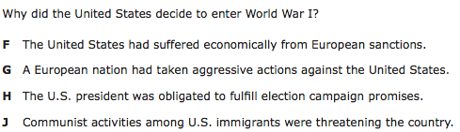
1.

2.

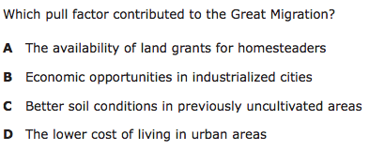
3.

5.

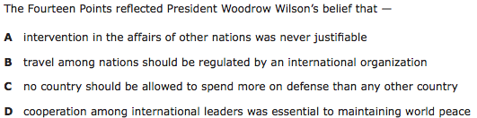
4.

