World War II Causes Review Homework

Alliances (List the countries fighting in each side)
Axis | Allied
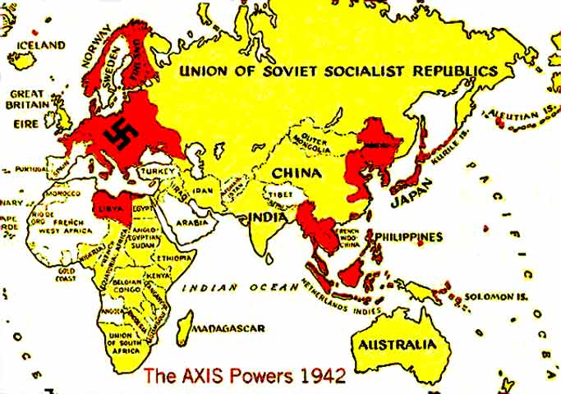 | 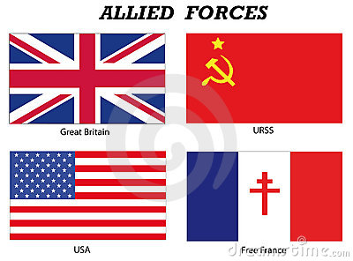

Causes (Give a breif summary of the causes of WWII by answering the questions below)

How did WWI and the Treaty of Versailles cause WWII?

How did appeasment cause WWII?

How did the rise of totaliarinism cause WWII?

Rise of Dictators (Match the dicators below with their description)
1. Adolf Hitler _____________
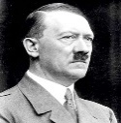
A. Dictator of Soviet Union Russia who was in alliance with the Allied Powers during WWII to fight Germany. After the war, tensions will grow between him and the U.S. over power and communism.

B. Dictator of Italy and leader of the National Fascist Party who formed an alliance with Germany and Japan during WWII.

C. Dictator of Nazi Germany who started World War II with the invasion of Poland in 1939. He was central figure to the Holocaust.

D. Military dictator of Japan who formed an alliance with Germany and Italy during WWII and was responsible for attack on Pearl Harbor

2. Joseph Stalin _____________
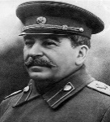

3. Hideki Tojo _____________
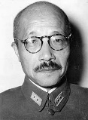

4. Benito Mussolini _____________

Cause-and-Effect (Briefly describe the effects of each of these events)

Navi Germany invades Poland on September 1, 1939

Japan bombs U.S. naval base in Pearl Harbor, Hawaii in 1941

Germany invades Soviet Union Russia in 1941

Germany invades France in 1940

