WORLD WAR II

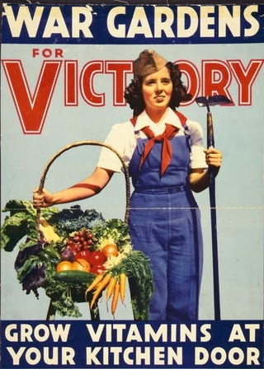
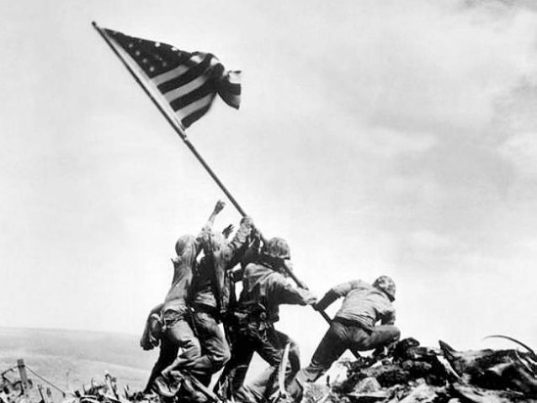
World War II was a global war that lasted from 1939 to 1945 (with the U.S. joining in 1941). It involved all of the world's great powers- eventually forming two opposing military alliances: the Allies and the Axis. In a state of total war, the major participants threw their entire economic, industrial, and scientific capabilities behind the war effort, erasing the distinction between civilian and military resources. WWII was the deadliest conflict in human history. Over 60 million people were killed, most of which were civilians. It included massacres, the deliberate genocide of the Holocaust, strategic bombing, starvation, disease and the first use of nuclear weapons in history. After the Allied victory in 1945, WWII has dramatically altered the political alignment and social structure of our world to this very day.

Recall Warm-Up
Read the paragraph and analyze the images above to jog your memory. Describe the major economic, social, and political issues from this era.

Economic | Social | Political
WORLD WAR II
Need to Know Terms/People
- Allied versus Axis Powers- Alliances (Allied= Great Britain, France, Soviet Union, US) VERSUS (Axis= Nazi Germany, Fascist Italy, and Imperial Japan)
- Holocaust- Genocide during WWII in which Adolf Hitler’s Nazi Germany systematically murdered six million European Jews, around two-thirds of Jewish population of Europe (Anti-Semitism) (Concentration/Death Camps)
- Appeasement- Diplomatic policy of making political or material concessions to an aggressive power in order to avoid conflict (allowed Hitler to take European land but ended with invasion of Poland in 1939)
- Dictator- A ruler with total power over a country, typically one who has obtained power by force.
- Pearl Harbor- US military base on Hawaii that was bombed by Japan on December 7, 1941= US enter war
- Bataan Death March- 76,000 prisoners of war (66,000 Filipinos, 10,000 Americans) were forced by the Japanese military to March 65 miles in the Philippines in 1942, causing many to die.
- Island Hopping- U.S. military strategy of securing and taking control of many small islands in the Pacific in order to move the U.S. army closer to Japan
- Battle of Midway- Huge naval victory and turning point for U.S. in the Pacific Theater (Front) by inflicting devastating damage on the Japanese naval fleet
- Manhattan Project- Research and development in Los Alamos, New Mexico by the U.S., Great Britain, and Canada to produce the first nuclear weapons (Used on Hiroshima and Nagasaki= Japan surrender in 1945)
- Homefront- Mobilized citizens to help fight war, Selective Service/military enlistment, rationing, war manufacturing, “Rosie the Riveter”, victory gardens, war-bonds
- Executive Order 9066 - Presidential order by F.D.R. in 1942 that authorized the incarceration of Japanese Americans to internment camps in the U.S
- D-Day (Invasion of Normandy)- Allied invasion of Normandy, France in 1944 that resulted in the liberation of Western Europe from Nazi control; largest seaborne invasion in history
- Liberation- To set free; Holocaust victims in camps freed by Allied forces in 1945
- WWII Heroes- Navajo Code Talkers (US soldiers use Native American languages to transmit secret messages), Tuskegee Airmen (African American military pilots), Flying Tigers (Chinese American military piolets)

Significant People Descriptions

Adolf Hitler
President Franklin D. Roosevelt

President Harry S. Truman

General Dwight D. Eisenhower

General Douglas MacArthur

General George S. Patton
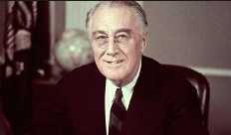
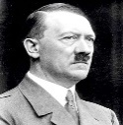

Joseph Stalin
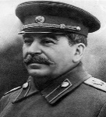

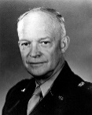
Hideki Tojo
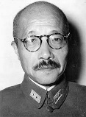

Benito Mussolini

WORLD WAR II
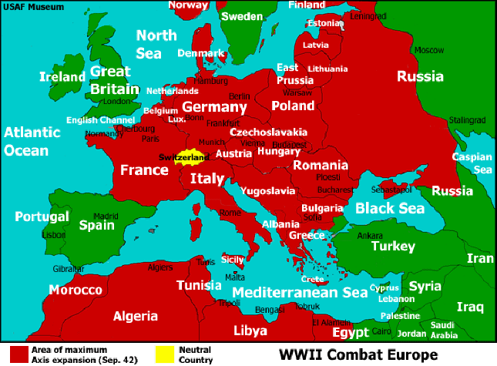
Overview
Allies:

Axis:

WWII started on September 1, 1939 when…

U.S. entered WWII in 1941 when…

WWII ended in ____________. The winner was…

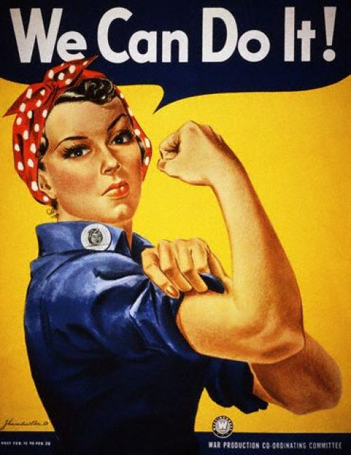
Homefront
How did Americans mobilize and help the war effort at home?

Pacific Front
How did Allied Forces fight in the Pacific?

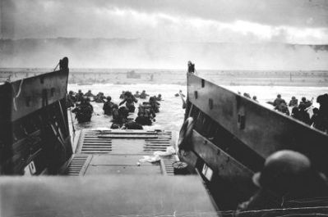
European Front
How did Allied Forces fight in the Western Front?

How did Allied Forces fight in the Eastern Front?

WORLD WAR II: STAAR Questions

1.

2.

3.

5.

4.

