Description | Event | Image
 | Unrestricted Submarine Warfare
A German U-boat torpedoed this ocean liner traveling from New York to England which sunk the ship in 18 minutes and killed over 1,000 people including 128 Americans
 |  | 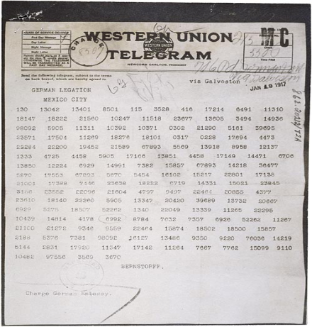
Reasons for U.S. Entry Into WWI: Matching Bell-Ringer

To prevent supplies from getting to the Allies, German U-boats sunk boats without warning- a violation of international law

The U.S. had been selling many products and loaning a lot of money to the Allies and (privately) wanted them to win the war

A note from the German government asking Mexico to attack the U.S. was intercepted and published in newspapers

Sinking of the Lusitania

The Zimmermann Telegram

Economic relationships with the Allies
