Historical Inquiry Documents
Document #1 13 May, 1915

Sent by the President of the United States, Mr. Woodrow Wilson.
The Cunard liner, Lusitania, was sunk by a German submarine on May 7,1915, with a loss of more than 1,100 passengers and crew, including 124 Americans.
The following note was sent by President Wilson under the signature of Secretary of State William Jennings Bryan.

Department of State,
Washington, May 13, 1915
To Ambassador Gerard:[German ambassador to the U.S.]
In view of recent acts of the German authorities in violation of American rights on the high seas which culminated in the torpedoing and sinking of the British steamship Lusitania on May 7, 1915, by which over 100 American citizens lost their lives, it is clearly wise and desirable that the Government of the United States and the Imperial German Government should come to a clear and full understanding as to the grave situation which has resulted.
The sinking of the British passenger steamer Falaba by a German submarine on March 28, through which Leon C. Thrasher, an American citizen, was drowned; the attack on April 28 on the American vessel Cushing by a German aeroplane; the torpedoing on May 1 of the American vessel Gulflight by a German submarine, as a result of which two or more American citizens met their death and, finally, the torpedoing and sinking of the steamship Lusitania, constitute a series of events which the Government of the United States has observed with growing concern, distress, and amazement.
… the Government of the United States was loath [didn’t want] to believe -- …that these acts, so contrary [against] to the rules…and spirit of modern warfare, could have the…sanction [approval] of that great [German] Government. … [The U.S. Government]is expecting action on the part of the… German Government….
Expressions of regret and offers of reparation [money] in case of the destruction of neutral ships sunk by mistake, … cannot justify or excuse a practice,….

Document #2

The Zimmerman Note

This English translation of the telegram -- from Arthur Zimmermann, German Foreign Secretary, to Heinrich von Eckardt, the German Ambassador in Mexico -- is transcribed from a telegram of Walter H. Page, American Ambassador in Great Britain, to Robert Lansing, American Secretary of State (File No. 862,20212/69)….
The telegram was sent January 16, 1917.

We [Germans] intend to begin on the 1st of February unrestricted submarine warfare. We shall endeavor in spite of this to keep the United States of America neutral. In the event of this not succeeding, we make Mexico a proposal of alliance on the following basis: make war together, make peace together, generous financial support and an understanding on our part that Mexico is to reconquer the lost territory in Texas, New Mexico and Arizona. The settlement in detail is left to you. You will inform the President of the above most secretly as soon as the outbreak of war with the United States of America is certain….
Signed, Zimmermann

Document #3
Woodrow Wilson’s 4th note of protest to the German Government: May, 1915 (excerpt)
The rights of neutrals in time of war are based upon principle,…. It is the duty and obligation of belligerents [countries at war] to find a way to adapt the new circumstances to them.
The Government of the United States and the Imperial German Government are contending for the same great object,…. They are both contending for the freedom of the seas.
The Government of the United States will continue to contend for that freedom, …without compromise and at any cost. It invites the… cooperation of the… German Government.
Repetition by… German naval vessels… in contravention [an illegal act] of those rights must be regarded by the Government of the United States, when they affect American citizens, as deliberately unfriendly.

Document #4
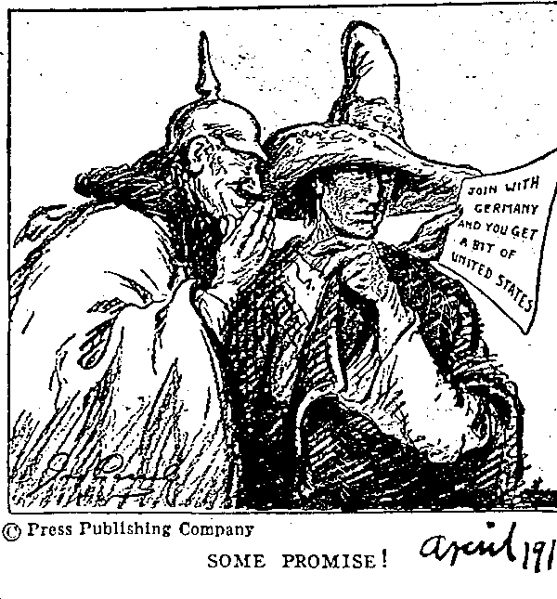

Document #5 Cartoon: GERMANY UNDER ALL March 12, 1915
This is another cartoon that parodies a national anthem. In this case it is the old German imperial anthem Deutschland Uber Alles, literally translated as Germany Over All.
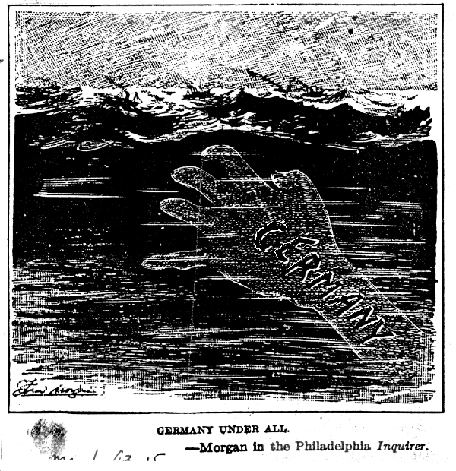

Document #6
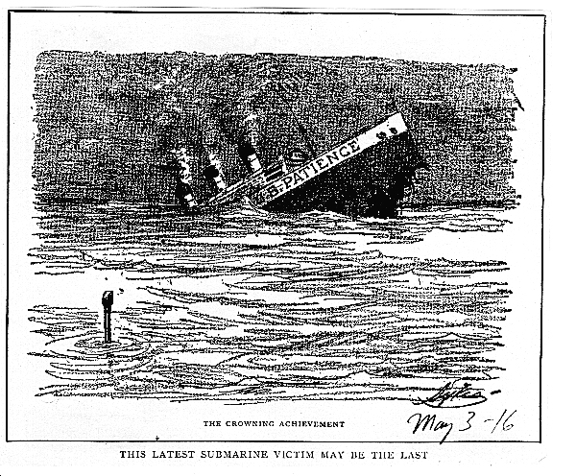

Document #7
