WWI Homework Questions: USE YOUR STRATEGIES

1.) How did technology make WWI different from previous conflicts?
- The destructive nature of the new weapons meant that war was over quickly
- The destructive technology meant more casualties of war
- Technology meant less men were required to fight in the war
- Technology meant that generals were able to control the fighting fully

2.) A major cause of World War I was
- A decline in the policy of imperialism
- The existence of opposing alliances
- An increase in acts of aggression by England
- The spread of communism throughout Europe

3.) How did imperialism lead to World War I?
- European nations were eager to show their military might by fighting with one another.
- European nations all felt that their nation was superior to others.
- European nations were eager to gain the colonial territories owned by their rivals.
- European nations were eager to take sides with other nations.

4.) Which statement best describes the relationship between World War I and the Russian Revolution?
- World War I created conditions within Russia that helped trigger a revolution
- World War I postponed the Russian Revolution by restoring confidence in the czar
- The Russian Revolution inspired the Russian people to win World War I
- World War I gave the Czar’s army the needed experience to suppress the Russian Revolution

5.) “The responsibility for the death of so many American citizens, which is deeply regretted by everyone in Germany, in a large measure falls upon the American government. It could not admit that Americans were being used as shields for English contraband (smuggled goods, weapons). In this regard America had permitted herself to be misused in a disgraceful manner by England. And now, instead of calling England to account, she sends a note to the German government.”
- from Vossische Zeitung, May 18, 1915

Which of the following statements best describes the sentiments of the writer? (SSHIPPS)
- The sinking of the Lusitania was a tragic mistake
- America was right to blame Germany for the attack
- The American government had failed to protect its own citizens
- England should keep its vessels off the Atlantic Ocean

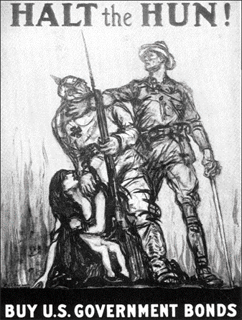

6.) Look at the poster above and answer the following question. (OPTIC)
What impact might this poster have had on the American attitude about Germany in WWI?
- The Germans cared for the welfare of women and children
- The poster indicates the Germans sought to purposely harm women and children
- The Germans were a threat to U.S. government bonds
- The Germans were being stopped from helping women & children

7.) Why might the word ‘futile’ be a good description for trench warfare?
- It illustrates the terrible nature of war
- It illustrates how the idea of fighting war was flawed
- It illustrates how pointless trench warfare was because it consisted of soldiers with little or no protection attacking a well-defended enemy
- It illustrates how smart trench warfare was because of the new weaponry

8.) How did the American Expeditionary Forces help the Allies win WWI?
a. They convinced German troops to rebel against their leaders.
b. They held secret talks with the German Kaiser, which led to the armistice.
c. They fought alongside the Allies during the last battles.
d. They helped win the Battle of the Argonne Forest.

9.) What effect did World War I have on women?
a. More than one million women entered the work force.
b. Women were made into slaves.
c. Women were allowed to fight on the front lines.
d. Women were not allowed to go out in public.

